EUDIS Defence Hackathon 2025 Guidelines (May 9-11)
This document outlines the terms and guidelines for the EUDIS Defence Hackathon 2025, which will be held at the Rēzeknes Technoloģiju Akadēmija (Rēzekne Technology Academy). EUDIS Defence Hackathon 2025 is organized by Riga Technical University (RTU) in cooperation with the Ministry of Defence Republic of Latvia. The hackathon is supported by the Ministry of the Interior, the State Border Guard, SIA Latvijas Mobilais Telefons, SIA BELSS, SIA Baltic Photonics, Rēzekne Academy of Technologies, SIA Unilab, Manabalss.lv, the Latvian Federation of Security and Defense Industries, the National Defence Academy of Latvia, the Latvian Chamber of Commerce and Industry and other major companies and defense industry representatives in Latvia and the Latgale region.
Registration platform: https://taikai.network/eudisLATVIA/hackathons/EUDIS-LATVIA

Event Overview
The EUDIS Defence Hackathon aims to foster innovation in the defence sector by bringing together teams from various backgrounds to develop solutions for the challenges outlined in the event. Teams will compete to create prototypes and ideas that can potentially contribute to strengthening the European Defence Sector.

Important Dates
The key dates for the event are as follows:
• Registration Deadline: May 5, 2025, 23:59 CET
• Hackathon Weekend: May 9-11, 2025
Late registrations during the Hackathon Weekend may be accepted at the local organizers' discretion, but only if the local organizers have announced additional applications for available spots.

Topics
1 Enhanced Situational Awareness and Tactical Surveillance Systems
This challenge aims to deliver affordable and portable surveillance systems that will improve the situational awareness of Ukrainian military units. Surveillance systems should be designed for ease of deployment, able to withstand harsh environments and rapid movement across diverse terrains or in the air/water.
2 Cost-Effective Protective Gear for Frontline Defence
This challenge focuses on equipping soldiers with high-quality, lightweight protective gear that is both affordable and easy to produce. With scalability as a key requirement, these solutions must be designed for efficient, low-cost production to ensure that adequate protection can be made available to a large number of troops, contributing to Ukraine's capacity for sustained defence.
3 Advanced Medical Support for Frontline Care
This challenge seeks to develop advanced, AI-driven tools that support both medics and soldiers in quickly diagnosing injuries and determining the priority of care under high-pressure conditions. Soldiers in the field often face immediate medical needs or need to assist injured comrades before a medic arrives, and AI-powered systems can play a crucial role in guiding these fast-response actions.

Eligibility
Hackathon is organized as a team-based Hackathon. While individuals are invited to register for the event, all individual Hackathon participants will be required to either form a team with other participants or join a pre-existing team. To participate in the EUDIS Defence Hackathon, all participants must meet the following eligibility criteria:
• Teams and individuals with and without ideas are welcome to apply.
• Participants must be 18 years of age or older.
• Participants must be citizens and residents of any EU Member States, Norway, or Ukraine.
• Participants must not have engaged in activities that could threaten national security.
• Each team must include at least two (2) participants and have a designated Team Leader.
•The maximum number of team members is 5. You can search members via TAIKAI, Discord platform, have put together a team before being able to compete in the Hackathon.
• At least one member must be fluent in English and able to represent the team in checkpoint and mentoring sessions throughout the duration of the Hackathon.
• If you are a solo applicant at the time of the idea submission, start working on gathering a team with the needed expertise to build your idea into a prototype.
• One participant can represent only one team within the Hackathon.
• The team must confirm and ensure their availability to participate throughout the entire Hackathon period and follow the rules and requirements set out by the event organizers.
• To participate in the competition and be a candidate for one of the prize awards - the team should have participated in 75% of Hackathon activities.

The Approval of participants
The approval of participants for the event takes place in two stages:

In stage 1 - access to the Taikai platform is approved for those participants who have submitted complete information about themselves by filling out the application form.

In stage 2 - participation in the Hackathon weekend is accepted:
1.1 after the authenticity of the information provided by the person has been verified, including whether the person has been involved in activities that could harm national security.
1.2 fulfilled the following additional eligibility criteria:
1.2.1. Participant must be in a team to take part in the Hackathon Weekend;
1.2.2. Each team must have appointed a Team Leader;
1.2.4. The Team Leader must confirm the final team composition of the team to the RTU, till the start of the Hackathon Weekend;
1.2.5. Teams must have at least three (3) participants, but not more than 5.
1.2.6. Teams must have an idea to work on, the latest at the start of the Hackathon Weekend.

Registrations should be submitted on the event website (https://taikai.network/eudisLATVIA/hackathons/EUDIS-LATVIA )
no later than 2025 May 5th 23:59 (EEST). Unless the registration deadline is extended.
When registering for the event, you can indicate whether you need transportation to get to the event. Latvian local organizers will cover a limited number of transportation seats.

All registrations will be reviewed and the event organizational committee will validate their eligibility. If participation in the hackathon is not approved, local organizers are not required to explain the reason for the rejection in detail.

Hackathon Weekend

Content

A hackathon is a three-day event that aims to support teams in building prototypes in defined thematic areas.

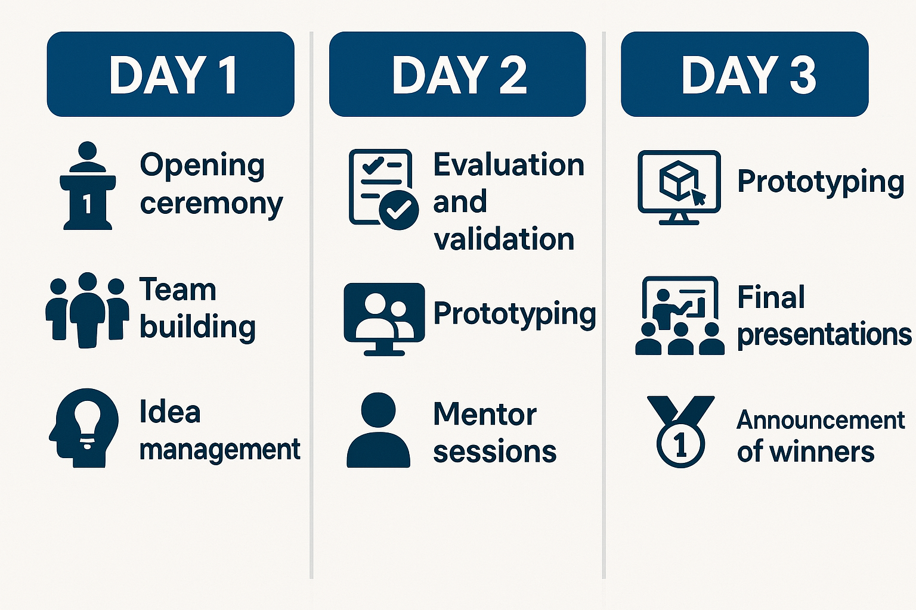

Rules

The following rules apply during the Hackathon Weekend:
• Extremely high-security measures will be taken throughout the hackathon, so participants must be prepared to present their identification documents and personal belongings so that local organizers can verify compliance with security regulations.
• Teams must develop their solutions during the Hackathon Weekend only. No work should begin before the event.
• Teams should ensure their availability for the entire Hackathon Weekend and adhere to the event rules.
• Solutions cannot be explosive or endanger the safety of others; the focus must be on protection.
• The ownership of any intellectual property developed by participants during and within the scope of the Action will remain with the individual participants.
• All information presented publicly (eg. via pitches) during the Hackathon(including initial ideas, developed concepts, technical details and business models) is considered as public domain knowledge.
• The organisers have the right to edit the Requirements and guidance document
(Guidelines) until the beginning of the Hackathon.
• Not following the rules and requirements set out by the event organizers can disqualify the team from the Hackathon at the discretion of the event organizers.
• If security service representatives notice any violation that may harm national security or other participants during the hackathon, the participant may be disqualified at any stage.
•All participants are expected to behave professionally and respectfully throughout the event. Harassment or any form of inappropriate behavior will not be tolerated. The following are explicitly excluded: alcohol, tobacco, religion, politics, violence, pornography, and illegal drugs.

Evaluation criteria

Each Team is required to submit a single completed project page on the Hacking Platform containing the following:
▪ A short summary of the project.
▪ Brief biographies and their roles in the team of all team members.
▪ Optionally, a pitch deck or link to a video or screen capture of the prototype.
▪ Link with the theme and one of the challenges: data, information, services, and signals used.
▪ Any unique hardware used in the project.

Only upon completion of all required fields is your application considered complete. The submission deadline is 11 May 2025 at 12:30 CET. You are encouraged to submit your application before the deadline in case IT issues arise. Each Team can submit only one Hackathon Submission.

Hackathon Submissions that have not been submitted, or those submitted past the abovementioned deadline, are not eligible for evaluation and will under no circumstances be reviewed by the jury. Following the application deadline, eligible submissions will be reviewed by the jury.

Each hacking team must present its project idea and must be able to answer the jury's questions. Presentation duration 3 minutes.

All submissions will be evaluated and scored by the jury on four criteria:
 | Criteria | Weight
 | Relevance of the idea, solution or prototype with regards to the EU Member | 25%
 | States/Norway/Ukraine defence needs and the defence hackathon themes and
 | challenges;
 | Innovativeness of the idea, solution or prototype, its uniqueness, and its value | 25%
 | created for defence end-users;
 | The comparable progress made of the teams’ ideas, solutions or prototypes | 30%
 | during the hackathon weekend;
 | Quality of the team (defence, technical and business expertise, understanding of | 20%
 | the thematic area, commitment to the project, ability to present the idea,
 | solution, prototype or business model).

The jury makes the final decision on the selection. These decisions shall be final and binding for all participants and teams in the Action in any selection procedure. The jury decision is final and cannot be appealed. The jury don't provide grounds of justification of the team evaluation.

Prizes
Prizes for the winning teams of the EUDIS Defence Hackathon 2025 are as follows:
• 1st place: 5,000 EUR
• 2nd place: 3,000 EUR
• 3rd place: 2,000 EUR
The cash prize is divided equally among all team members. If it is not possible to divide equally, the team captain is credited with additional cents, and the others receive in equal shares. In accordance with the laws and regulations in force in the Republic of Latvia, personal income tax is withheld from the cash prize to be paid.
Additional prizes may be awarded by sponsors and supporters at their own initiative.
The selection process of the winners of the local Hackathon Weekend is executed exclusively in English via pitching in the local hackathon.
The winning Team (1st place) will also be invited to participate in the Mentoring Programme and the subsequent EU-Wide Pitching competition for eight (8) Hackathon weekend winners.

